3.2 Tutorial :

a1=[1 -0.8];
b1=[2 0 -1];
[H1 omega]=freqz(b1,a1,4)
[H2 omega2]=freqz(b1,a1,4,'whole')

H1 =

5.0000
2.8200 - 1.3705i
1.8293 - 1.4634i
0.9258 - 0.9732i

omega =

0
0.7854
1.5708
2.3562

H2 =

5.0000
1.8293 - 1.4634i
0.5556
1.8293 + 1.4634i

omega2 =

0
1.5708
3.1416
4.7124

3.13 Basic:

a)

b)b1=[1];
a1=[0.1 1];
[H omega]=freqz(b1,a1,100);
freqs(b1,a1)

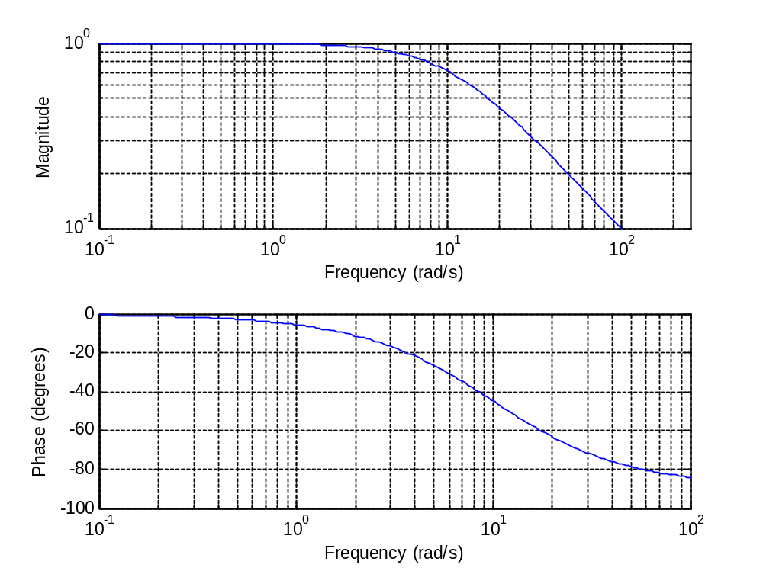

c)

4.2 Basic:
a)

b-c)
tau=0.01;
T=10;
t=[0:tau:T-tau];
N=T/tau;
y=exp(-2*(t-5))+exp(2*(t-5));
Y=fftshift(tau*fft(y));
plot(t,Y)

